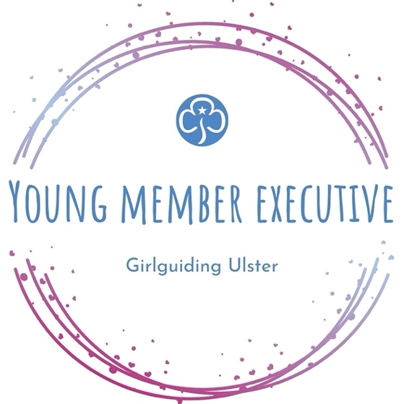
YOUNG MEMBER EXECUTIVE
APPLICATION FORM

At Girlguiding Ulster, we want to ensure that we listen to our young members, and provide them with an organisation that meets their needs, as well as something they can be proud of. It is vital that we hear your voice. If you are aged 14 to 18, I really encourage you to consider joining our Young Member Executive. This is a fantastic opportunity for you to make a real difference to the future of Girlguiding Ulster. Working together, we will continue to enhance and expand the experiences and opportunities of our young members, always keeping girls at the heart of Guiding.
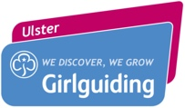
Milly Greer
Assistant Chief Commissioner

ROLE DESCRIPTION

The Young Member Executive will be a team involving a representative from each County of Girlguiding Ulster. We’re looking for girls with a passion for Guiding, aged between 14 and 18. As a representative, you will have responsibility for sharing and promoting opportunities to the girls in your county, as well as gathering thoughts and ideas of how girls think Guiding should continue to develop in Ulster. The role will initially be for a period one year, with the potential for a further one-year extension.

ROLES AND RESPONSIBILITIES

Members of the Young Member Executive will commit to:

- Attend all scheduled meetings (approximately 4 virtual meetings per year, and 2 in-person meetings)
- Champion the voice of young members within their Counties and across Girlguiding Ulster
- Share communications and information across their County where necessary, with the approval of Ulster Executive
- Notify Ulster Executive as soon as practical, if any matter arises which may be deemed to affect Girlguiding Ulster
- Take forward any projects, ideas or events as requested by the Ulster Executive
- Take part in any Task and Finish Groups as required

Members of the Young Member Executive can expect:
- To be provided with complete, accurate and meaningful information in a timely manner
- To be given reasonable time to make decisions
- To have open and honest discussions

APPLICATION FORM

Name:
Age:
Email address:
Mobile nº:
Membership Nº * :
Unit Name:
Unit Leader:
*If you do not know your membership number, please request this from your unit leader.

Tell us about yourself, a little about your involvement in Girlguiding, and why you love it. How will this help you fulfil your responsibilities as a representative on the Young Member Executive?

What are your thoughts on the current opportunities offered by Girlguiding for your age group? Do you have any suggestions or ideas of additional opportunities Girlguiding Ulster could offer?

Do you feel there is a section (Rainbows to Rangers) which lacks opportunities? If so, which section, and can you suggest examples of how this could be improved?
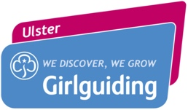
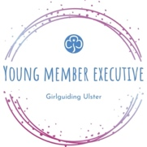
Please email completed application forms by 5pm on Friday 24th June 2022, to milly@girlguidingulster.org.uk.

