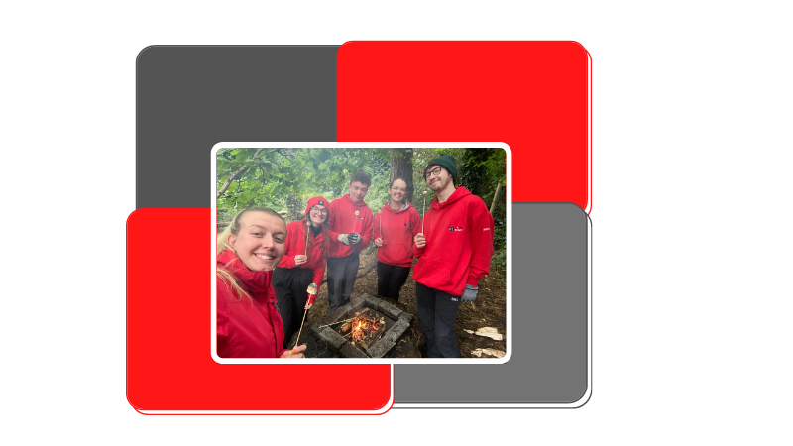

Multi Activity Instructor

Multiple contract types available:

Casual contract beginning November 2023
Short term contract beginning 1st March 2024.

Salary: Minimum wage for age per hour during training period rising to a maximum of £10.92 per hour once qualified. Prior experience and NGB qualifications taken into consideration.

Closing Date: Thurs 19th October 2023 at 12pm

The Role

Job Title: Multi Activity Instructor
Reports to: Operations Manager/Activities Supervisors

Overall purpose of job
The Multi Activity Instructor is responsible for the instruction of all the outdoor activities, assisting with the delivery of all programme aspects at Lorne such as food service, housekeeping and ensuring the safety of all groups including maintaining the site and equipment.

Main areas of responsibility
Main Duties
1. To assist and lead in the supervision of children participating in activities and to oversee the general safety and behaviour.
2. To instruct groups of young people/adults of all ages in a range of instructor led on-site activities.
3. To deliver safety/welcome briefs to participants using the activities.
4. To follow procedures and systems of work to ensure that safety is always maintained.
5. To ensure that activities are run efficiently and that problems are resolved in a timely manner.
6. To ensure that the site and equipment is maintained and stored in line with defined standards.
7. To identify the need for repair/replacement of activity equipment and report this to the Outdoor Activities Manager.
8. To complete any documentation required.
9. To deal with as appropriate and report any safety hazards to the Outdoor Activities Manager at the earliest opportunity.
10. To appropriately act if any situations arise as per the Emergency Action Plan using the 2-way radio system.
11. To assist with housekeeping duties including cleaning bathrooms, sanitising touch points, brushing and mopping floors, setting up furniture and any other duties required.
12. To assist when required with all other departments at Lorne this includes: Catering, to help with food service to ensure clients receive an overall high standard experience and camping, helping to put up and taken down tents, assisting with campsite equipment and facilities
13. To undertake any training, as required.

This Job Description is an outline of the post as it is currently perceived and may be subject to review as a result of a changing and developing organisation.

The Person

Criteria | Essential or Desirable
Skills
Previous experience working with children and young people | E
Excellent communication skills | E
Ability to be a team player | E
Ability to use initiative and work unsupervised | E
1st Aid Qualification | D
Any recognised National Governing Body Awards for Outdoor Activities provided by Lorne Estate i.e. Archery GB Instructor Award for Archery | D

Training

We provide all the necessary training needed to fulfil this role during November/December 2023 and January/February 2024. There is an essential training weekend 6/7 January 2024 so applicants must be able to attend this. Other dates will be agreed to suit applicants and will be during evenings and weekends. It is an essential requirement for this role that you are available to attend these dates. Prior experience may exempt you from parts of this training and will be considered on an individual basis.

This course will cover everything you need to become an outdoor instructor at Lorne ready to have a positive impact on the lives of young people. It includes group and behaviour management, leadership, confidence building as well as the technical skills needed to deliver activities such as high ropes, archery, bushcraft and climbing.

It is a fun and interactive course mostly delivered outside using our range of outdoor equipment.

Employment Details

Contract Type
This post is either a casual contract or short-term contract from March 2024 for up to 8 months. To be discussed and arranged with individual applicants.

Location
This role is based at Lorne Estate, Holywood, Co. Down.

Holiday Entitlement
Casual contracts receive holiday pay twice per year and short term contracts receive 20 days (pro-rata) of holiday per year plus bank holidays

Life Assurance
This cover is provided under a separate policy from the date of joining the organisation.

Medical Information and Access NI
Upon successful appointment you will be required to complete a confidential occupational health questionnaire so we can consider our ability to make any reasonable adjustments where advised.

All members of Girlguiding Ulster staff undertake regulated activity on a frequent basis and therefore require an enhanced Access NI check. Girlguiding Ulster is located at Lorne which is a Training, Activity, Camp and Residential Centre. This means that all staff have the opportunity of being left unsupervised with children and young adults. Outdoor Activity staff are involved in the teaching and training of children and all other staff have the opportunity to be in a supervisory role

Safeguarding and GDPR training is provided to all employees upon appointment.

Employee Assistance Programme (EAP)
Our EAP is free and confidential independent help, information and guidance to you and your immediate family 24/7. It also offers up to eight counselling sessions.

Car Parking
All employees can park securely at Lorne Estate while they are working free of charge.

Uniform
All staff are provided with a uniform to wear.

How to apply

Please send your C.V. to tracey@girlguidingulster.org.uk. Ensure your C.V. demonstrates what makes you suitable for the role

The closing date is Thursday 19th October 2023 at 12pm. We ask that you make your submission as soon as possible as we reserve the right to close vacancies at any time, when we have received sufficient applications.

Interviews will be held on Saturday 28th October 2023
Unfortunately, we are unable to give feedback to candidates not shortlisted for interviews. We do provide verbal feedback upon request to candidates interviewed.
Girlguiding Ulster values the differences that a diverse workforce brings and is committed to inclusivity, and to employing and supporting a diverse workforce. While Girlguiding’s young members may be women only, our staff team is mixed gender. We welcome applicants from all backgrounds.
Please contact Tasha Crawford , Operations Manager if you need any further information: tasha@girlguidingulster.org.uk

